Algorithm for file updates in Python

Project description
My job is the create an algorithm that uses python to check whether or not the allow list of IP addresses contains addresses that have been identified on the remove list. If there are some that should be removed, I need to remove them from the allow list file.

Open the file that contains the allow list
The open() function allowed me to open the allow list file.. The open import is the 1st parameter of the function. To only open the file I wouldn’t need the second parameter of “r” which allows me to read it.
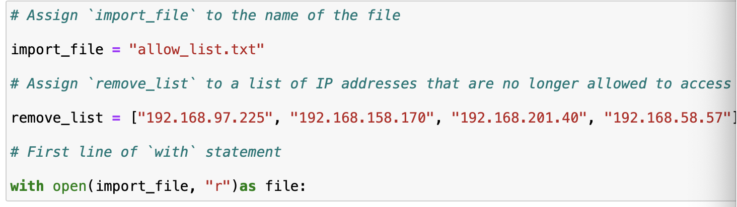

Read the file contents
The “r” function allowed me to read the contents of the allow list file as shown in the screenshot above. The “r” function preceded by the comma is the second parameter of the function.

Convert the string into a list
The “.split()” allowed me to convert the string of IP addresses into a list. Which resulted in each IP address being on a new line in the allow list file.
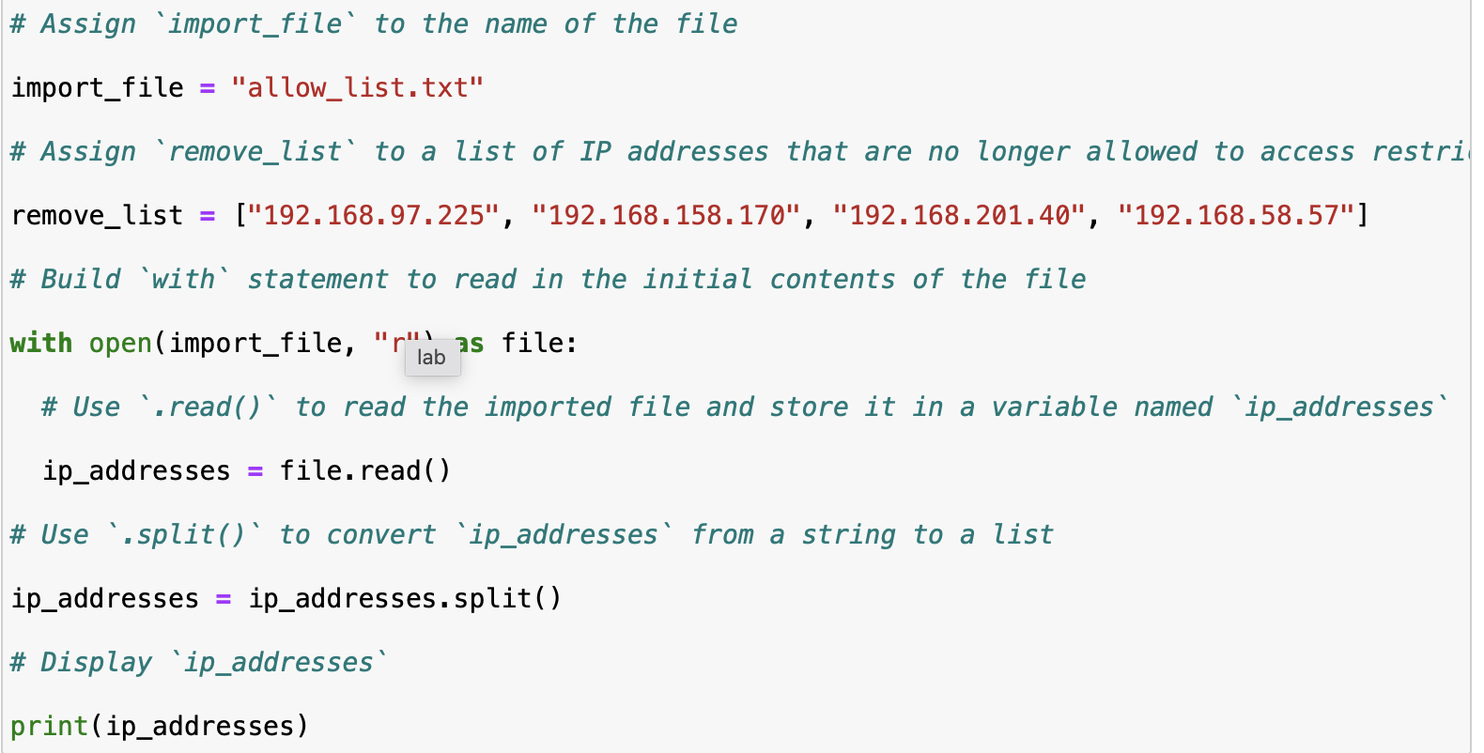

Iterate through the remove list
Here I used the “import_file” to assign to those IP’s that were allowed. The assignment of the remove_list = to assign IP addresses that were no longer allowed to access the system. “with open(import_file, “r”) allowed me to see the original content of the file to be able to compare it to the remove list file to print out those that should be removed.
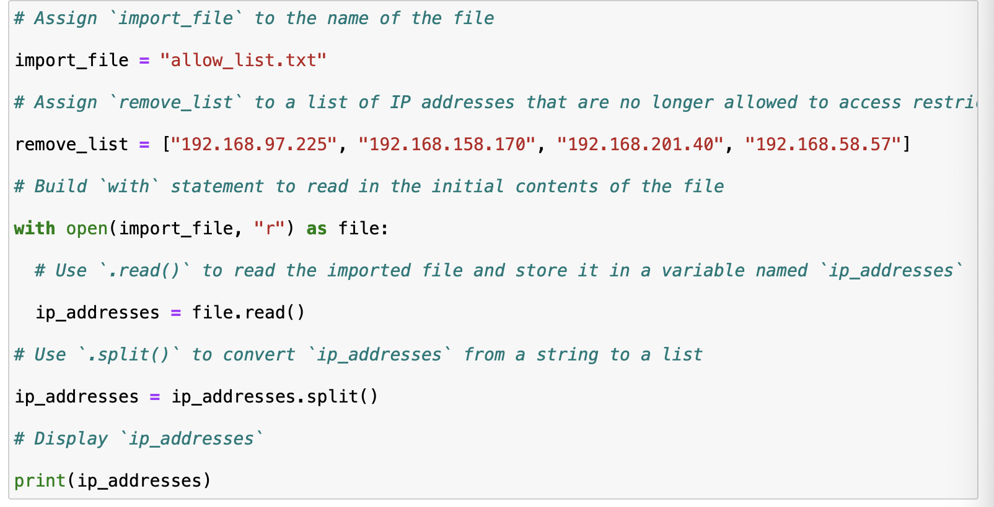

Remove IP addresses that are on the remove list
[Add content here.]
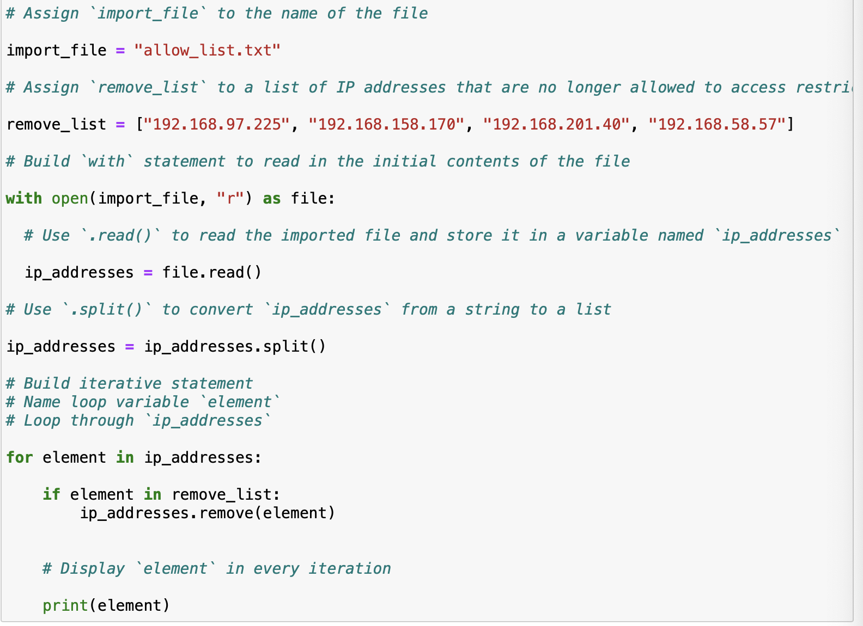

Update the file with the revised list of IP addresses
[Add content here.]



Summary
[Add content here.]

